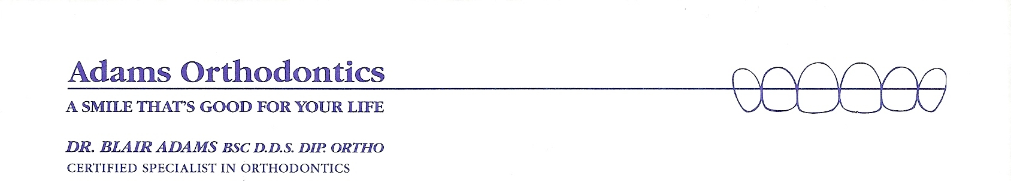
HISTORY FORM FOR TEMPOROMANDIBULAR DISORDER
Name:____________________________________ Date:___________________
Describe what you think the problem is;
What do you think caused this problem;
Are you presently under care of a physician or have you been in the last year? YES NO
Physician’s name________________________________ Condition treated
Name of medication(s) you are currently taking:
If you have had any major dental treatment in the last two years; please circle;
Orthodontics Periodontics Oral Surgery Restorative Date(s) of the Third Molar (wisdom tooth) extraction(s)
Do any of you activities hold your head or jaw in an imbalanced position?
(Phone, computer work, swimming, musical instrument) Describe:
Do you sleep with an unusual head position? YES NO DO NOT KNOW
Are you aware of any habits or activities that may aggravate this condition?
Describe:
What can you do to make your pain worse? _____________________________________
CURRENT STRESS FACTORS: (Please circle each factor that applies to you)
Death of Spouse Major Illness or Injury Major Health Change in Family
Business Adjustment Divorce Pending Marriage
Financial Problems Pregnancy Career Change
Fired from Work Marital Reconciliation Taking on Debt
Death of Family Member New Person Joins Family Marital Separation
Other;_________________________________________________________________________
SYMPTOMS:
(Circle each symptom that applies)
HEAD PAIN, HEADACHES, FACIAL PAIN EAR PROBLEMS
Forehead L R Hissing, Buzzing, Ringing, Roaring Sounds.
Temples L R Ear Pain without infection
Migraine Type Headaches Clogged, Stuffy, Itchy Ears
Maxillary Sinus Headaches (under the eyes) Balance Problems- Vertigo’
Cluster Headaches Diminished Hearing
Occipital Headaches (back of the head)
Hair and/or Scalp Painful to Touch NECK AND SHOULDER PAIN
Tired, Sore Neck Muscles
EYE PAIN Back Pain, Upper and Lower
Eye Pain- Above, below or behind Arm and Finger Tingling
Burring of Vision Shoulder Aches
Drooping of the Eyelids
Light Sensitivity OTHER PAIN? If so, please describe:
Pressure behind the Eyes

Is there any additional information that can help us?

Disc Problems
Have you heard popping or clicking sounds in your ears Yes No
Has the popping or clicking stopped Yes No
Do you hear grinding sounds in your ears Yes No
Do you have pain in front of your ears when you bite down Yes No
Do you have pain in front of your ears when opening your mouth Yes No
Do you have pain in front of your ears when not using your jaw Yes No
Does your jaw only open part way (When did it first happen, how often) Yes No
When the jaw only opens part way, can you manipulate it to open fully Yes No
Does your jaw open and then not close Yes No

Muscle Problems
Does your jaw only open part way Yes No
Does the amount you can open vary from week to week Yes No
Do you have pain below your ear(s) when you bite down Yes No
Does it hurt in your temples when you bite down Yes No
Do you have neck aches of difficulty turning your head Yes No
Do you have headaches Yes No
Do you have shoulder or hack problems Yes No
Do you clench or grind your teeth Yes No
Do you chew gum Yes No
Do you awaken at night with facial pain Yes No
When you cant open your mouth fully, is it mostly in the morning Yes No
Does your jaw pain seem worse in the morning Yes No
Does your jaw pain seem worse in the afternoon Yes No
Does stress affect any of the above symptoms Yes No
Are you in an emotional or stressful period of life Yes No
Do you have ulcers, stomach trouble or bowel problems Yes No

Airway
Do you have difficulty breathing through your nose Yes No
Do you have allergies Yes No
Do you have difficulty closing your lips Yes No
Have your tonsils and/or adenoids been removed Yes No
Do you have speech clarity problems Yes No

Progressive Condylar Resorption
Has your bite changed Yes No
Has your chin moved backwards Yes No
Have you heard popping sounds in your ear(s) Yes No
Has the popping stopped Yes No
Does your jaw only open part way Yes No
Do your teeth hit unevenly Yes No
Do you posture your lower face forward Yes No
Do you clench or grind your teeth Yes No
Have you injured your face, head, neck or jaw Yes No
Do you have arthritis Yes No
Are any of your other joints painful, swollen or stiff Yes No
Have you had rheumatic or scarlet fever Yes No
Women; are you or could you be pregnant Yes No
Do you take birth control pills Yes No
Do you take hormone replacements or steroids Yes No

Chronology
Have your symptoms increased or worsened Yes No
Do you attribute the symptoms to one incident Yes No
When did you first notice your problems; date; Yes No

What do you do to control your symptoms: hot/cold packs, physical therapy/ chiropractor,
diet change, anti-inflammatory pain medication, limit your jaw movements, injections
Whom have you consulted about this: physiotherapist, chiropractor, TMJ specialist, pain clinic, oral surgeon, orthodontist, general dentist, ENT, neurologist, other.
Have you had treatment: splint equilibration (grinding of the teeth), physical therapy/ chiropractic, occlusal reconstruction, orthodontics, TMJ surgery, jaw surgery, stress counseling, other.

