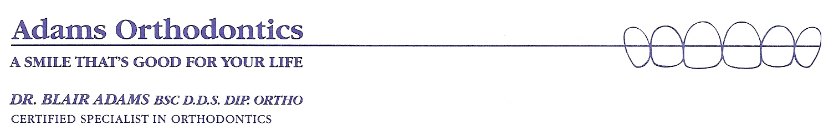
Orthodontic Patient Information Sheet

Patient’s Number:_________________ Age:____ Birth Date:____/____/____ Sex:_____ M D Y
Patient’s Name: _________________________________________________________
Home Address: _________________________________________________________
City: _____________________________ Prov. __________ P.C. _______________
Home Phone Number: _______________ E-mail address:_______________________
Father: __________________________ Work Number:_______________________
Father’s Occupation: _____________________________________________________
Mother: ___________________________ Work Number: ______________________
Mother’s Occupation: _____________________________________________________
Siblings’ Name: ___________________________________________ Age: ________
____________________________________________ Age: ________

Is this appointment prompted by: JAW JOINT PROBLEMS or ORTHODONTICS?
Have you consulted an orthodontist before? Yes or No
Whom may we thank for referring you to us? _______________________________
What are your main reasons for consulting Dr. Adams? _________________________

Are there any other family members with similar problems? Yes or No

Patient’s Dentist: ____________________ Patient’s Physician: ___________________
Is there an Emergency contact person?
Yes – Name: ______________________ Phone Number: ______________________
Relationship: ______________________

Signature: ___________________________________ Date: ______/_______/_____

INFORMATION TO PATIENTS
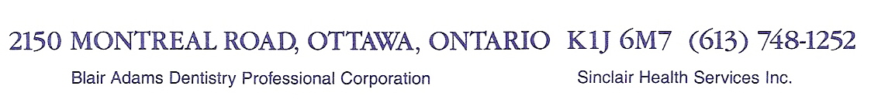
Blair Adams Dentistry Professional Corporation (Adams PC) provides all professional orthodontic services rendered to you. Sinclair Health Services Inc. (Sinclair Health) is an independent corporation, the shareholders of which are members of Dr. Adams’ family. Sinclair Health provides all technical health care services rendered, including dental hygiene services, x-ray services, assisting services and other technical services to you under a cost-sharing arrangement with Adams PC. Although Sinclair Health is not a health profession corporation, all technical health care and dental hygiene services are provided under the clinical supervision of Dr. Adams.

Patient Medical History

Patient Name: ______________________________ Date: ____________________

Are your jaw joints uncomfortable? Yes / No
Do they ever make clicking/popping/crunching noises? Yes / No
Do they ever get locked/stuck/hard to open? Yes / No

Date of last physical exam? ____________________________________________

Are you now under the care of your physician? If yes, condition being treated:
________________________________________________________________

Have you ever had any serious illness or operations? If yes, give details:
________________________________________________________________________
________________________________________________________________________
________________________________________________________________________

Have you had an injury involving your face, head or neck: Yes / No

Do you have, or have you had any of the following:
Heart murmur, heart problems, heart surgery pacemaker Yes / No
Allergy to medication Yes / No
Are you currently taking medication Yes / No
Have you had serious trouble with your teeth or dental work? Yes / No
Rheumatic fever or rheumatic heart disease Yes / No
Vascular disease (High/Low blood pressure) Yes / No
Sinus trouble/Hay fever/Asthma Yes / No
Fainting spells or seizures Yes / No
Hepatitis/Jaundice/liver disease/mononucleosis Yes / No
Arthritis/Rheumatism/Kidney trouble Yes / No
Tuberculosis/persistent cough or coughing blood Yes / No
Syphillis/Gonorrhea or other venereal disease Yes / No
Do you have any blood disorder, such as anemia? Yes / No
Have you had surgery or radiation for any tumor or other condition
of the mouth or lips Yes / No
Are you pregnant? Yes / No
Osteoporosis? If yes, which medication? Yes / No

Please add anything you feel is important or any other disease or problem not listed above:

______________________________________________________________________________

INFORMATION TO PATIENTS
Blair Adams Dentistry Professional Corporation (Adams PC) provides all professional orthodontic services rendered to you. Sinclair Health Services Inc. (Sinclair Health) is an independent corporation, the shareholders of which are members of Dr. Adams’ family. Sinclair Health provides all technical health care services rendered, including dental hygiene services, x-ray services, assisting services and other technical services to you under a cost-sharing arrangement with Adams PC. Although Sinclair Health is not a health profession corporation, all technical health care and dental hygiene services are provided under the clinical supervision of Dr. Adams.

CONSENT FOR COLLECTION, USE AND DISCLOSURE OF PERSONAL INFORMATION
Privacy of information is an important part of how our office provides high-quality care. We understand the importance of protecting your information. We are committed to collecting, using and disclosing it responsibly. We also try to be as open and transparent as possible about the way we handle your information.
In this office, Dr. Adams acts as the Privacy Information Officer.
All staff members who come in contact with your personal information have been trained in the appropriate uses and protection of your information. They are aware of its’ sensitive nature.
Our goals are to ensure that:
We only collect necessary information and we only share information with your consent;
storage, retention and destruction of your personal information complies with existing legislation, and privacy protection protocols; plaster models of our patients’ teeth are kept on shelves behind glass doors; the presence of doors indicates that these models are private records that are not to be looked at without written authorization.
our privacy protocols comply with privacy legislation and the standards of our regulatory body.

How We Collect, Use and Disclose Patients’ Personal Information
This office will collect, use and disclose information about you for the following purposes:
to assess your health needs, advise you of treatment options and to deliver safe, effective, efficient patient care
to identify and to ensure continuous high quality service
to establish and maintain communication with you and to book and confirm appointments
to communicate with your general dentist and your other health-care providers, including dental specialists and physicians
to allow us to efficiently follow-up for treatment, care and billing
to provide the efficiency of our computerized check-in process your name must be displayed
when your treatment is complete, part of our celebration of the happy event is to display your smiling photo. This photograph does not include your name.
for teaching and demonstrating purposes on an anonymous basis
to complete and submit dental claims for third party adjudication and payment
to comply with legal and regulatory requirements, including the delivery of patients’
charts and records to the Royal College of Dental Surgeons of Ontario in a timely fashion, when required, according to the provisions of the Regulated Health Professions Act
to permit potential purchasers, brokers, accountants or advisors to evaluate our practice.
to deliver your charts and records to the dentist’s insurance carrier to enable the insurance company to assess liability and quantify damages, if any.
to prepare materials for the Health Professions Appeal and Review Board (HPARB)
to process credit card payments, direct bank account debits and to invoice for services.
to collect unpaid accounts
to assist this office to comply with all regulatory requirements
to comply generally with the law
By signing the consent section of this Patient Consent Form, you have agreed that you have given your informed consent to the collection, use and/or disclosure of your personal information for the purposes that are listed. If a new purpose arises for the use and/or disclosure of your personal information, we will seek your approval in advance.
Your information may be accessed by regulatory authorities under the terms of the Regulated Health Professions Act (RHPA) for the purposes of the Royal College of Dental Surgeons of Ontario fulfilling its mandate under the RHPA, and for the defence of a legal issue.
Our office will not under any conditions supply your insurer with your confidential medical history. In the event this kind of a request is made, we will forward the information directly to you for review, and for your specific consent.
When unusual requests are received, we will contact you for permission to release such information. We may also advise you if such a release is inappropriate.
You may withdraw your consent for use or disclosure of your personal information, and we will explain the ramifications of that decision, and the process.
Our office has a privacy code; copies of this code are available on request.

Patient Consent
I have reviewed the above information that explains how your office will use my personal information, and the steps your office is taking to protect my information.
I know that your office has a Privacy Code, and I can ask to see the Code at any time.
I agree that Adams Orthodontics can collect, use and disclose personal information about
________ , as set out above in the information about privacy policies.

signature print name

date signature of witness

INFORMATION TO PATIENTS
Blair Adams Dentistry Professional Corporation (Adams PC) provides all professional orthodontic services rendered to you. Sinclair Health Services Inc. (Sinclair Health) is an independent corporation, the shareholders of which are members of Dr. Adams’ family. Sinclair Health provides all technical health care services rendered, including dental hygiene services, x-ray services, assisting services and other technical services to you under a cost-sharing arrangement with Adams PC. Although Sinclair Health is not a health profession corporation, all technical health care and dental hygiene services are provided under the clinical supervision of Dr. Adams.
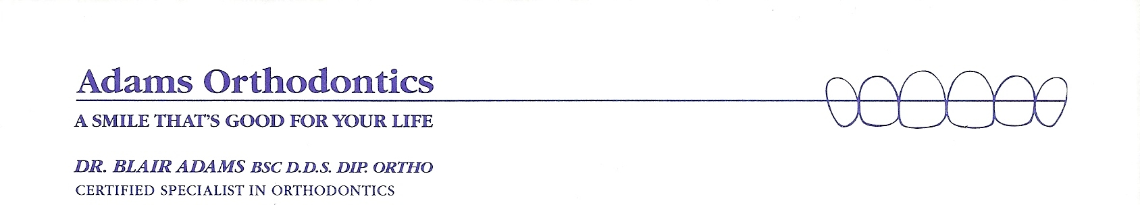
HOW DID YOU FIND US?

NAME:

DATE:

DENTIST’S NAME:

We are conducting this survey to see how our patients hear about us and what motivated you to call our office. Thank you in advance for your time! We are always looking for ways to improve our service to our patients.

Please circle the #1 to indicate the most important reason you called us for an orthodontic evaluation. Please circle the #2 to indicate any other ways you heard about our office. There should only be one #1 and as many #2’s as needed.

1 2 My dentist
1 2 My friend, neighbor or co-worker recommended you (Please specify whom)
1 2 A family member was treated/is being treated by Dr. Adams
1 2 One of our patients recommended you (Please specify whom)
1 2 My teacher or school nurse recommended you (Please specify whom)
1 2 Heard about you through a school talk, church or community activity (Please circle)
1 2 Your staff referred me to the office (Please specify whom)
1 2 Saw your yellow page listing
1 2 Received your postcard
1 2 Saw your office while surfing the “net”
1 2 Magazine/Newspaper (Please specify)
1 2 Saw your sign
1 2 Invisalign referred me
1 2 Other (please elaborate)

Thank you! We appreciate your thoughts! Dr. Adams and team

/tmp/in/input.doc


